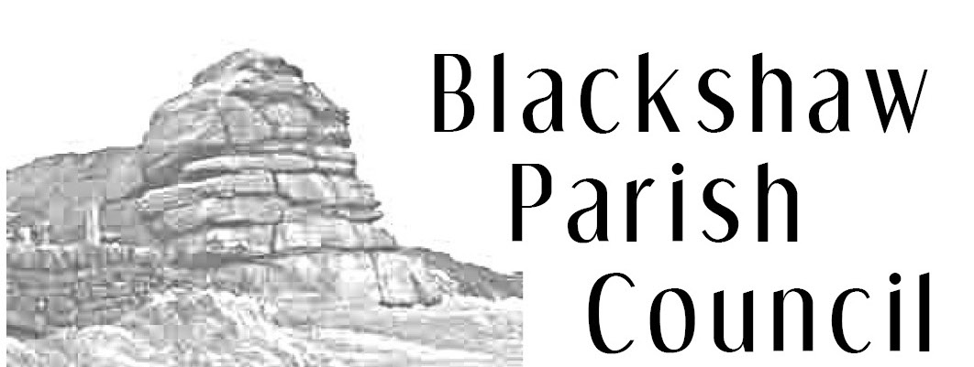
6 Adelaide St, Todmorden, OL14 5HT
blackshawclerk@gmail.com
01706 815155
www.blackshaw.net

Notice of Parish Council Meeting

You are hereby summoned to attend the meeting of Blackshaw Parish Council which will be held at 7.30pm on Monday 23rd August 2021 at Blackshawhead Methodists Church. The meeting will be open to the Press and Public

- To accept apologies previously notified to the Clerk.
- To receive declarations of interest in items on the agenda.
- To confirm the minutes of the Parish Council Meeting held on 26th July
- To receive information on matters arising from the minutes of Parish Council Meeting on 26th July
- To welcome new councillor Rachel Churchill and accept her signed Declaration of Office
- To receive a report from the Allotment Committee on the follow up visit following the issuing of a Letter of Improvement to one plotholder and discuss next steps.
- To discuss formalising terms of reference for the Allotment Committee
- To discuss a complaints policy for the Parish Council
- To discuss CCTV in the parish
- To finalise a rota for the Parish Council red tent at the Fete
- To consider planning related matters:-
  - Information on previous planning applications: 21/20070/TPO | Management of trees (including reduction to monoliths) | Gudger Glen View Road HX7 6DA Consent Granted
  - Planning Enforcement Issues: None
  - New planning applications
    - 21/20101/TPO | Fell five trees (Tree Preservation Order) | Wellside The Long Causeway Blackshaw Head Hebden Bridge Calderdale HX7 7JF
    - 21/01010/HSE | Erection of a single storey extension to rear, reinstatement of extension to cellar and works to be done to interior and exterior to property. | Hippins Farm Davey Lane Blackshaw Head Hebden Bridge Calderdale HX7 7JG

- To consider matters relating to highways, bridleways and footpaths:
  - Any update from Highways regarding the outstanding issues
  - To discuss the verges / drains in Blackshawhead

- To consider the following Financial matters:
  - 2021/2022 budget and balances and bank reconciliation.
  - To discuss a grant to sponsor students at Todmorden Climate Challenge College
  - To confirm payment of the allotments water bill to Business Stream
  - To confirm payment of the Clerk’s monthly salary and expenses

- To consider representative reports and invitations:
Dates of future meetings:
Parish Council Meetings: - 27th September, 25th October at Blackshawhead Chapel
Allotment Committee: - October 2021

Signed Catherine Bann
Clerk to Blackshaw Parish Council

