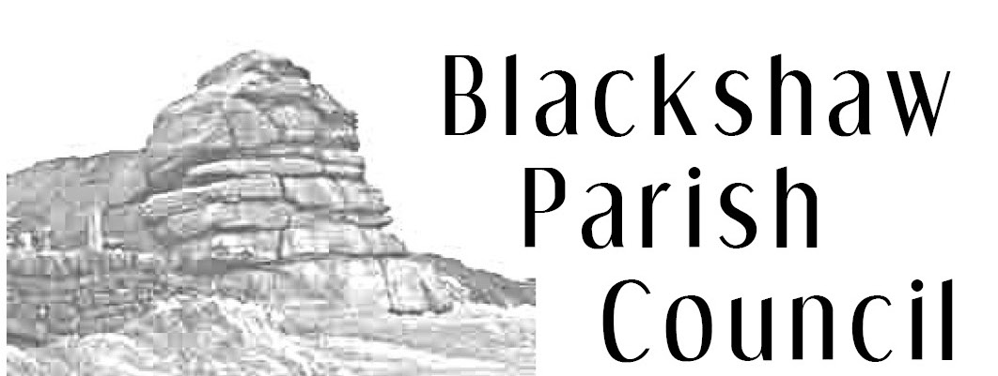
6 Adelaide St, Todmorden, OL14 5HT
blackshawclerk@gmail.com
01706 815155
www.blackshaw.net

Notice of Annual Parish Council Meeting

You are hereby summoned to attend the annual meeting of Blackshaw Parish Council which will be held at 7.30pm on Monday 17th May 2021 online on Zoom. The Annual Parish Meeting, which usually takes place prior, will take place on zoom on Monday 24th May at 7.30pm. The meetings will be open to the Press and Public, but anyone wishing to attend must contact the Clerk by 5pm on the day, who will then send a link/phone number to access the meeting.

- To elect the Chairman for 2021/22.
- To accept the Chairman’s declaration of Office and undertaking to observe Code of Conduct.
- To appoint a Vice-Chairman for 2021/22
- To accept apologies previously notified to the Clerk.
- To receive declarations of interest in items on the agenda.
- To confirm the minutes of the Parish Council Meeting held on 26th April 2021.
- To receive information on matters arising from the minutes of the Parish Council Meeting held on 26 April
- To update on the meeting with PCP regarding the community wind turbine
- To note the correspondence from Mr Murty regarding flood provision at Sandbed
- To review the parish specific policies for the Neighbourhood Plan
- To consider planning related matters:-
  - Information on previous planning applications: None
  - Planning Enforcement Issues:
    - Any update from Roy Rizvi or Richard Seaman
  - New planning applications - None

- To consider matters relating to highways, bridleways and footpaths:
  - To update on progress with the footpath mountain biking meetings
  - Any update from Highways regarding the outstanding issues
  - To discuss issues in the letter from a resident regarding the Bridestones area

- To appoint Parish Council representatives for 2021/2022:
  - Allotment committee (3)
  - Audit matters (1)
  - Yorkshire Local Councils Association (2)
  - Town and Parish Council Liaison Group (1)
  - Heptonstall Exhibitions and Richard Naylor Charities (1)
  - Friends of Colden Clough Nature Reserve (2)
  - Old People’s Welfare Committee (1)
  - Flood Resilience Group
  - Neighbourhood Plan
  - Any other appropriate organisation

- To consider the following Financial matters:
  - To certify Blackshaw Parish Council as exempt from external audit for fiscal year 2020/21
  - To note the Annual Internal Audit Report for 2020/21 included at page 4 of the Annual Governance and Accountability Return
  - To consider the Annual Governance Statement and to approve Section 1 - Annual Governance Statement 2020/21 for Blackshaw Parish Council on page 5 of the Annual Governance and Accountability Return.
  - To approve Section 2 - Accounting Statements 2020/21 for Blackshaw Parish Council on page 6 of the Annual Governance and Accountability Return
  - To approve the publication of documents required by Accounts and Audit Regulations 2015, the Local Audit (Smaller Authorities) Regulations 2015 and the Transparency Code for Smaller Authorities
  - Dates for the Exercise of Electors Rights
  - 2021/2022 budget and balances and bank reconciliation.
  - To discuss a grant to Heptonstall Exhibitions/Richard Naylor charities
  - To confirm payment of £250 to CROWS under S137
  - To confirm payment for the annual insurance premium to Zurich of £376.77
  - To confirm the honorarium payment to Barry Eccles for the internal audit
  - To confirm payment of the Clerk’s monthly salary and expenses

- To consider representative reports and invitations:
Dates of future meetings:
Annual Parish Meeting - 24th May on Zoom
Parish Council Meetings: - 28th June at Blackshawhead Chapel, 26th July, 23rd August
Allotment Committee: - October 2021

Signed Catherine Bann

Clerk to Blackshaw Parish Council

